Michael Reichenberger
Ward Hall 126
Kansas State University
Manhattan, KS 66506

Dr. Jeremy Roberts
Professor - ME 701
Ward Hall 137D
Kansas State University
Manhattan, KS 66506

Dear Dr. Roberts:

Please find enclosed my manuscript, “Review and Enhancement of Monte Carlo Foam Simulation Using Object Oriented Programming, and Message-Passing Interface”, which I would like to submit to you as part of the course requirements of ME 701.

This paper investigates the use of Monte Carlo simulation to predict the intrinsic thermal-neutron detection efficiency of porous media. Previous studies have shown the validity of such methods, but additional review of the simulation methods has suggested significant improvements are possible. The present work assessed the physical accuracy of the simulation environment, and re-designed the software using object-oriented practices to enhance flexibility and expand usability of the simulation. Additionally, message-passing interface (MPI) was utilized to reduce the execution time of the simulation.

Two significant physical flaws were discovered and corrected during this review, yielding a more reliable prediction of intrinsic thermal-neutron detection efficiency. The re-design using object-oriented practices enabled the development of numerous “preset foams” to be used, but also allows for the user to describe specific characteristics for optimization purposes. Finally, the use of MPI reduced the execution time for a characteristic problem (20cm thick, 100% Lithium-Fluoride impregnated foam using 10⁵ histories) from 78 seconds to 17 seconds (using only 4 nodes).

I thank you for your consideration and look forward to your decision.

Sincerely,
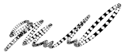

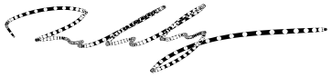

Michael Reichenberger
Proceedings of ME 701 (Development of Computer Applications in Mechanical Engineering)
ME 701
December 19, 2014, Manhattan, KS

Review and Enhancement of Monte Carlo Foam simulation using Object oriented Programing, and Message-Passing Interface

Michael Reichenberger
Kansas State University
Manhattan, KS, United States of America

Abstract
Foam materials saturated with neutron sensitive compounds are of interest as a viable replacement for ³He-based neutron detectors. Previous studies have shown the feasibility of ⁶LiF-saturated foam detectors as a valid replacement both experimentally and theoretically. However, the random geometry of foam material has previously limited the effective theoretical considerations for such materials to generalized approximations of detector efficiency based on the effective amount of neutron-sensitive material and effective charged-particle ranges. Neutron transport and subsequent charged particle energy deposition have been previously simulated using novel Monte Carlo methods in order to develop reaction-product pulse-height spectra, to determine intrinsic thermal-neutron detection efficiency, and to optimize material properties for open-cell foam neutron detectors. The present work re-assessed the physical accuracy of the former simulations, improves the flexibility of the simulation package by incorporating object oriented programing practices, and improves computation efficiency by utilizing message-passing interface. The new version of the foam simulation addresses flaws in charged particle tracking and is more easily adapted to other types of foams. Finally, the use of a message-passing interface significantly reduces the computation time by utilizing additional processing cores.
Motivation
Porous materials are under investigation as viable replacements for ³He-based neutron detectors [1]. Foam-based materials are of particular interest due to their extremely low cost and mass-producibility [2]. Previous research investigated the effectiveness of various configurations of ⁶LiF-saturated foam gas-filled neutron detectors experimentally and analytically [1]. However, the random nature of open-cell foam geometries limits the effectiveness of such analytical methods to generalized cases. Theoretical investigation of the intrinsic thermal-neutron detection efficiency of open-cell foam devices of various shapes and sizes, as well as predicting the resulting pulse-height spectra (PHS) for such devices, requires the development of novel Monte Carlo simulation techniques which can be used to emulate the heterogeneous and random geometry of the foam structure.
Monte Carlo simulation has long been used as a method to predict the solution to complex particle transport problems [3]. Developing appropriate probability distributions and accounting for all necessary physical phenomena presented in the problem are critical to accurate simulations. Properly modeling neutron and charged particle transport in porous foam materials necessitates the consideration of the struts and pores of the foam structure.
Table I: Comparison of the present work and prior work executing a characteristic simulation of a 20cm thick, 100% LiF impregnated foam using 10⁵ histories.
Objective
The present work was undertaken in order to verify the validity of previous work, and to improve the simulation usability. First, the previous simulation was profiled in order to discover which portions of the simulation required the most computation. After analyzing the profiling data in Table I, the simulation process was re-assessed from the ground up with object oriented programming practices in mind. Graphical displays of the data-flow are included in Appendix I.
Using the classes and methods described in the enhancements section of the present work, a simulation script was written to execute the Monte Carlo simulation amongst numerous nodes using message-passing interface (MPI). MPI execution was made possible by re-designing the simulation.
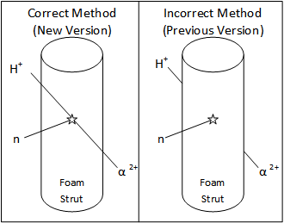
Previous Version
Function (Previous Work)Execution DemandTotal Execution Time78 secondsNew Random Number Generation13.61%Residual Energy Calculation10.49%Lead-in Distance Calculation8.07%Pore Generation6.79%Function (Present Work)------------------------Total Execution Time (1 Node)60 secondsTotal Execution Time (4 Nodes)17 seconds New Random Number Generation15.24%Residual Energy Calculation2.92%Lead-in Distance Calculation3.72%Pore Generation1.46%Fig. 2. Comparison of the correct and incorrect reaction product tracking used in the present and prior work respectively. The Incorrect method initializes each reaction product at the edge of the strut material with full energy. The correct method initializes the reaction products at the point of neutron interaction and reaction products loose energy traversing the strut material.
Former development roughly approximated the geometric characteristics of foam. Several physical parameters of the foam were characterized using a scanning electron microscope and are summarized in Table II. Additionally, the strut material composition was acquired from the foam manufacturer and appropriate thermal-neutron absorption cross sections were calculated based on the ⁶Li content and neutron absorption cross sections [4]. Finally the simulation lower-level discriminator (LLD) was set to 300 keV, conforming with previous research [1, 2].
Table II: Foam parameters used for Monte Carlo simulation.
Observed Parameter | Minimum |  | Maximum
Strut Thickness | 30 μm | 50 μm
Strut Length | 200 μm | 600 μm
Pore Diameter | 400 μm | 600 μm
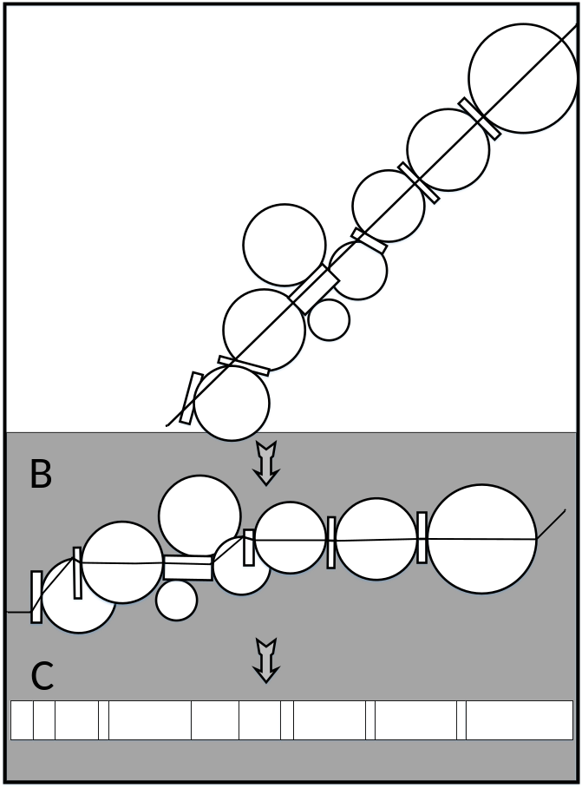
One challenge in simulating a foam material is developing the random geometry. Monte Carlo techniques were used in previous work to model charged particle transport through multi-layered, thin-film-coated devices composed of regular repeating structures [5]. However, the random geometry of the foam structure reduces the capability of the former methods to homogenized, simplified versions of the detector medium. A novel Monte Carlo technique called the “Dynamic Path Generation” (DPG) method was developed to reduce the complex, 3-dimensional, heterogeneous, and random structure of porous materials to a simple 1-dimensional particle path. Rather than using a static geometry (common for Monte Carlo particle transport simulations [3]), a dynamic path was generated for each particle history to emulate the foam features inside a defined space, as described in Fig. 1. By using a dynamic path to imitate the random structure of open-cell foam struts and pores, Monte Carlo simulations have been developed which are capable of accounting for these foam heterogeneities. Neutron and reaction product paths were both modeled using the DPG method. After a neutron interaction was simulated, charged particle transport was conducted using the residual energy method [6]. The previous work was used to predict the maximum intrinsic thermal-neutron detection efficiency of a 27.5% saturated ⁶LiF foam to be 65.90% ± 0.08% [7]. The prior work was used to suggest an optimal strut thickness of 13 μm [7]. The primary concern when analyzing the previous simulation was if the first charged particle path-length was accurately calculated. Prior work attempted to estimate length of travel for each reaction product through the strut in which a neutron interacts by calculating the distance to the edge of the strut using a complicated geometric calculation. Additionally, it was discovered, that the original work did not accurately account for the energy lost by reaction products traversing the first strut before entering the ionizing gas.
Fig. 1. Evolution of the particle path model used for dynamic path generation. (A) Illustrates the physical path of a particle through the foam with struts and pores modeled as cylinders and spheres. (B) Demonstrates how the same path can be represented by a particle incident on the same struts and pores with different trajectories. (C) Shows the interpretation of the particle path length through each medium which was used for the Monte Carlo simulation.

Enhancements
Simulation enhancements include three categories: bug fixes (improving accuracy), object-oriented design (enhancing flexibility), and MPI capabilities (increasing execution speed).
Accuracy Improvements
The objective of the foam Monte Carlo simulation is to predict the intrinsic thermal-neutron detection efficiency for various types of neutron sensitive foams. Using the predictions from the simulation, experiments can more quickly focus on developing the most effective radiation detectors rather than spending time characterizing various foams. During the analysis of the prior work, errors in charged particle tracking were discovered, which suggested that the results may have over-estimated intrinsic thermal-neutron detection efficiency. The previous simulation was not accurately reducing charged particle energy to account for the energy loss through the first strut, instead birthing all reaction products at the surface of a strut. This error greatly increased the average ionization energy for each neutron interaction. The situation is further depicted in figure 2.
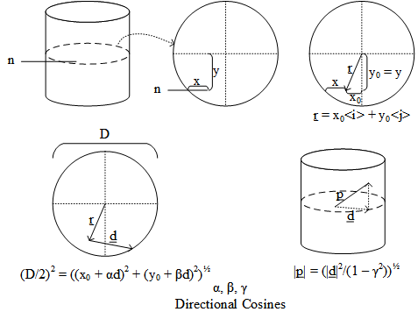
Additionally, the prior work attempted to use geometry to find the reaction product path-length. Current work uses vector tracking to determine reaction product path-length in the three-dimensional strut rather than settling for a less-accurate two-dimensional approximation. The simulation process to find the reaction product path-length through the first strut is illustrated in Fig. 3. When a neutron interacts in a strut, the penetration distance (x) and offset length (y) are known. The strut-relative interaction location (x₀, y₀) can be calculated. After randomly selecting an ejection angle (from 4π), the directional cosines (α, β, γ) are determined. The path-length (p) to edge of the strut is then calculated. The cases where the reaction products exit through the top or bottom of the strut are also considered, but no depicted in Fig. 3. Once the reaction product path-length is determined, the residual energy method can be used to calculate the energy of the reaction product leaving the strut [6].
Fig. 3. Reaction product path-length determination for the first strut.
By using vector tracking for the reaction product path-length calculation, in addition to correctly adjusting reaction product energies, the current work represents a more accurate simulation of the physical phenomena of concern.
Flexibility Enhancements
The prior work required significant code modification in order to facilitate any variation in foam parameters. One objective of the present work was to develop a more flexible version of the simulation to ease optimization trials and enable the users to test more types of foam. Object oriented programing practices were utilized to improve usability. The following classes were developed with numerous preset foams for selection. Additionally, the users is now able to easily track numerous parameters for future statistical analysis. Various optimization codes can be written using the classes developed in the present work, and expansion to other geometries is far simpler than in the previous work.

The classes in described below were developed in increase the flexibility of the simulation:

Run Manager:
Purpose: Manage histories and feed foam information into other objects. Compiles the ionization, interaction rate, and other statistical data from each history for analysis after simulation.
Uses: History, Foam, RNG
History:
Purpose: Transports the neutron and reaction products for a single particle history. Calculates the ionization of gas in the pores.
Uses: Foam, RNG, Neutron, Reaction Product
Random Number Generator (RNG):
Purpose: Provides a distinct set of random numbers for use in a single history. Incorporates the capability to “skip-ahead” in the random number list in order to enable multi-process execution.
Foam:
Purpose: Container for data pertaining to the foam geometry and material. Also holds numerous pre-set foam parameters for easy foam selection.
Uses: Path Element, Material
Path Element:
Purpose: Defines the individual constituents of the foam (struts and pores). Has an average thickness value (± σ) and material properties. Also has the capability to generate a random thickness (about the average) when given a random number (from 0 – 1).
Uses: Material
Material:
Purpose: Contains neutron absorption cross-sections, density, composition, and reaction-product ionization data for the material which makes up the foam path-elements.
Uses: None
Particle:
Purpose: Parent class for neutrons and reaction-products. Contains path history list, name and location information.
Uses: None
Neutron:
Purpose: Inherits from the particle class, but also has methods to test for an interaction and generate reaction-products. When reaction-products are created, the neutron also determines the first path-length for each reaction product.
Uses: Foam, RNG, Reaction-Product
Reaction-Product:
Purpose: Inherits from the particle class, but also possesses an energy variable and initialization methods to set the energy for various reaction products which are created from different neutron interactions. Additionally, contains methods to access ionization data in the material class and determine ionization through the various path elements. Reports ionization in gas pores to the history.
Uses: Foam
Execution Speed Improvements
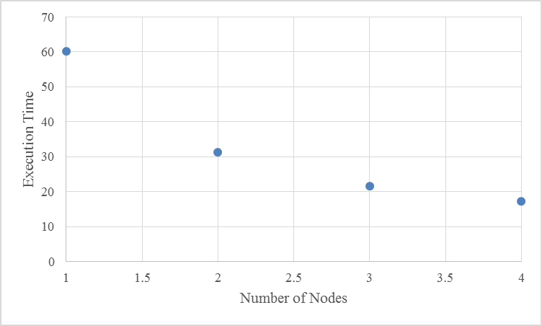
Monte Carlo simulation is a natural candidate for multi-process execution. Each particle history is nearly independent from every other history. Providing each execution node with a distinct set of random numbers to use for each history is one challenge with developing multi-nodal Monte Carlo simulations. Using independent sets of random numbers is important to prevent correlations between various physical phenomena in the simulation [3]. Several methods were used to resolve the random number generation problem, and in the end, a random number generator was used which can “skip-ahead” in the random number list. Using a random number generator which can “skip-ahead” made striding (designating a specific number of random numbers for each history) possible and improved execution speed without impeding simulation reproducibility. The results of MPI execution with 1, 2, 3, and 4 nodes are presented in Fig. 4. Multi-node execution improved execution speed by over 300% (using 4 nodes instead of 1). Finally, when compared to the previous work, the present work represents a significant improvement in simulation speed. The previous work was capable of executing 10⁵ neutron histories in 77 seconds. When using a single node, the present work executes 10⁵ neutron histories in 60 seconds and using four nodes can complete the simulation in 17 seconds (78% time saving).
Fig. 4. Comparison of simulation execution time for 10⁵ neutron particle histories using various numbers of nodes.
Future Improvements
The primary concern for future work revolves around verification of the simulation using experimental data. Previous experimental data has not been well-characterized, but presents a different intrinsic neutron detection efficiency than the present work. Simulating a 2cm thick, 4.5% ⁶LiF saturated foam, the simulation predicts an intrinsic thermal-neutron detection efficiency of 3.48% ± 0.06%. Experimental data reported an intrinsic thermal-neutron detection efficiency of 7.3% for 10 2mm thick samples of the same characteristics, tested in series [2]. After investigating the measurement method for the experimental data (because no error was presented in the measurement) the validity of the reported efficiency is now in question. In the future, experimental validation of the simulation should be conducted.
Foam characterization can also impact the accuracy of the simulation. The foam parameters listed in Table I were compiled from relatively few foam samples. Properly characterizing the foam parameters would provide more accurate physical simulation and should improve the simulation results.
Expansion of the simulation to include additional types of foam would expand usability. Currently, only lithium impregnated foams are supported. Other research is interested in investigating the efficiency of coated carbon foams, and metal-structured foams. This expansion will include characterization studies, and will also include additional capabilities in the simulation to support struts of different shapes (various polygons) and more importantly layers of neutron-reactive coatings. The goal will be to determine the optimal neutron-reactive coating thickness and predict the intrinsic thermal-neutron detection efficiency of such devices.
Current experimental research uses coated foam material as an alternative to the impregnated foams supported by the present work. Expanding the simulation to include coated foams of various geometries enables experimental verification to be conducted. Experimental verification requires far more analysis than the present simulation. Charge extraction from the bulk of the foam sample can be impeded by the foam structure. Background radiation can induce significant measurement error when using low efficiency samples for experiments. Also, design and construction of a detector housing can impede progress. Careful experimental design will be necessary to conduct a valid verification of the present work. However the detector optimization process will benefit greatly from the predictions of the present work.
References
[1] Kyle A. Nelson, James L. Neihart, Todd A. Riedel, Aaron J. Schmidt, Douglas S. McGregor, "A novel method for detecting neutrons using low density high porosity aerogel and saturated foam," Nuclear Instruments and Methods in Physics Researsh A, vol. 686, pp. 100-105, 2012.
[2] Kyle A. Nelson, Steven L. Bellinger, Benjamin W. Montag, James L. Neihart, Todd A. Riedel, Aaron J. Schmidt, Douglas S. McGregor, "Investigation of Aerogel, Saurated Foam, and Foil for Thermal Neutron Detection," in IEEE Nuclear Science Symposium, Valencia, Spain, 2011.
[3] William L. Dunn, J. Keneth Shultis, Exploring Monte Carlo Methods, Academic Press, 2012.
[4] National Nuclear Data Center, "Evaluated Nuclear Data File (ENDF)," Brookhaven National Laboratory, 2014.
[5] D.S. McGregor, M.D. Hammig, Y.H. Yang, H.K. Gersch, R.T. Klann, "Design considerations for thin film coated semiconductor thermal neutron detectors - I: basics regarding alpha particle emitting neutron reactive films," Nuclear Instruments and Methods in Physics Research Section A, vol. 500, no. 1-3, pp. 272-308, 2003.
[6] J.K. Shultis, D.S. McGregor, "Calculation of ion Energy-Deposition Spectra in Silicon, Lithium-Fluoride, Boron, and Boron Carbide," College of Engineering, Kansas State University, Manhattan, KS, 2007.
[7] M.R. Reichenberger, R.G. Fronk, J. K. Shultis, S.R. Stevenson, N.S. Edwards, K.A. Nelson, D.S. McGregor, “Monte Carlo Simulation of Energy Deposition by Neutron Reaction Products in Lithiated Foam Using Dynamic Path Generation,” in IEEE Nuclear Science Symposium, Seattle, WA, 2014.

Appendix I - A
Graphical display data-flow of the previous work:

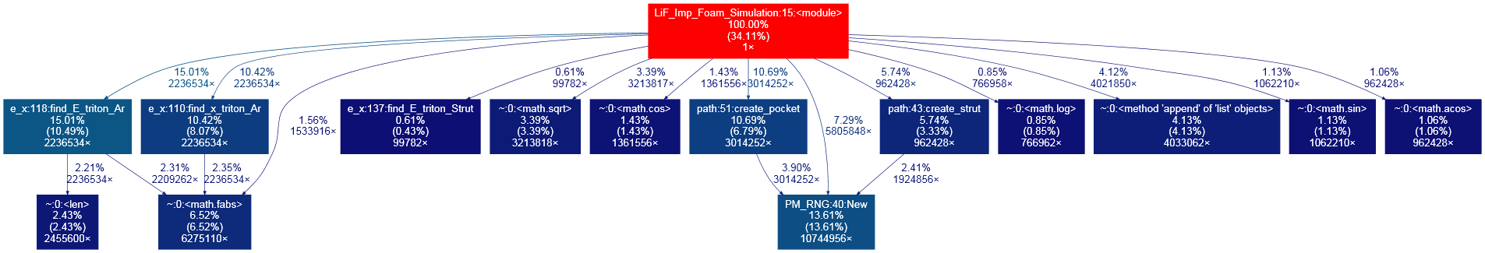

Appendix I – B
Graphical display of the data-flow for the present work:

